BOARD OPPORTUNITY  The Calgary International Children’s Festival is looking to expand its Board of Directors. Do you believe in giving ALL children in Calgary access to quality, live arts experiences?  We are looking for Board members that will help garner financial support for the Festival, as well as providing governance and stewardship. In addition to Board meetings and Committee work, Board members are expected to participate in our Kidsfest After Hours fundraising dinner and to attend Festival Events each May. | 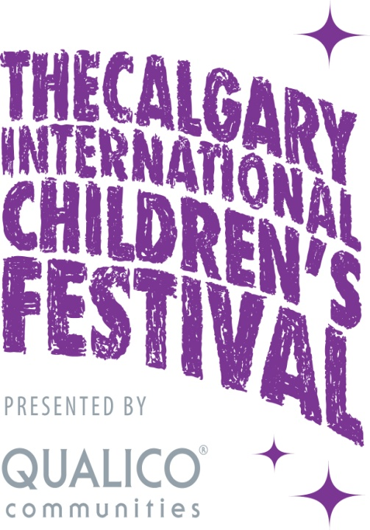
For more than 30 consecutive seasons, Calgary International Children’s Festival (Kidsfest) has hosted performances and workshops by celebrated artists from around the globe.
Every year Kidsfest features some of the world’s foremost artists producing work for young audiences, striving to help children discover the world around them, dream of possibilities and develop their full potential through the arts.

The four day festival presents critically acclaimed performances, with an emphasis on showcasing Canadian and international work and engaging our diverse community.

You can learn more at www.calgarykidsfest.ca or contact Carri Clarke, Chair of the Board, directly at clarkecd@telusplanet.net.

