Alberta Culture Days Grant Funding Now Available!
30 DAYS TO DISCOVER, EXPERIENCE AND CELEBRATE
Virtual and In Person, Indoors and Outdoors
Alberta Culture Days 2020: September 1 to 30

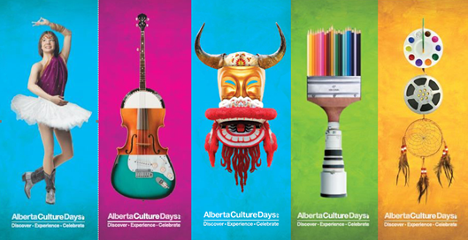

We understand the stressful time nonprofit organizations are going through. As this situation continues to evolve, we look forward to working with artists and partners to develop new meaningful ways to connect through culture. Alberta Culture Days is encouraging community organizations to explore and transform how this celebration is shared with Albertans.
We would like to encourage everyone to help us plan an outstanding celebration in September. It’s time to put the call out for artists, volunteers and organizers — Alberta Culture Days is coming! Across the province, plans are starting for the largest provincial celebration of arts, heritage, culture and community. How are you going to share your unique and amazing culture with Albertans in these unusual times?
With current restrictions on all events and public gatherings, we will be working with community organizers on establishing Alberta Culture Days online events and small in person events.

Anything from online art classes to singing competitions, to online cooking classes and dance lessons – imagine the possibilities. There is no shortage of online platforms to show off your cultural celebrations this year and not only with your community but far beyond. Zoom, WebEx, MS Teams, Facebook Live, Instagram Live, YouTube Live…you name it! At your service to engage with art and culture lovers everywhere. You can also pre-record an event and post it online. Use our event planning tips and tools to help plan your events.
Alberta Culture Days is your opportunity to reach out to new audiences and showcase your organization and community. Every community’s unique culture is on display for Albertans and the world to enjoy. Join us in this unique celebration of our culture!
Once again, the Government of Alberta is providing funding to assist community organizations in hosting Alberta Culture Days events. Grant applications are now open.
Month of the Artist has moved to September and to complement this initiative, Alberta Culture Days Celebration Sites will have the opportunity to host their events/activities from September 1 to 30.
Applications will close July 16, 2020. More information and application forms can be found at AlbertaCultureDays.ca.
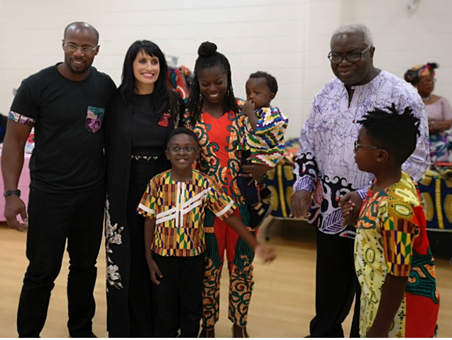
Pictured above: African Canadian Professional Network Association
Photo: Alberta Culture, Multiculturalism and Status of Women

Apply for funding and join us in the celebration of Alberta Culture Days, September 1 to 30.

We want you to be a part of our celebration! Apply now to become a Feature, Host or Pop Up Celebration Site for Alberta Culture Days celebrations.

Alberta Culture Days 2020 Celebration Sites must:
• provide culturally-related programming during the month of September:
o 3 days for Feature Sites
o 2 days for Host Sites
o 1 day for Pop Up sites

Visit AlbertaCultureDays.ca for more details. This site also features a number of event planning resources and customizable promotional tools.

We look forward to having you join us for Alberta’s largest celebration of our culture during Alberta Culture Days September 1 to 30, 2020.

