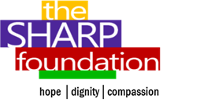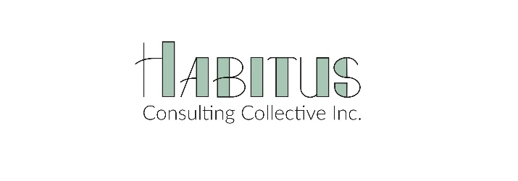
CALL FOR PUBLIC ARTISTS

Project Name: Learn Together, Recover Together, Resilient Together: South Calgary
Artist Fee: upto $7000 (including materials)
Proposal Deadline: October 5th, 2020
Funder: City of Calgary- Change Can’t Wait Fund
Lead Organizations: SHARP Foundation & Habitus Consulting Collective
Introduction: The SHARP Foundation proposes to use a community storytelling approach to reduce stigma and build resiliency in the community of South Calgary. The project will include a series of facilitated dialogues in the community, to hear how community members are managing their mental health, coping and recovering during the pandemic. Through these dialogues the goal is to build collect stories of community resiliency, share learnings and increase cohesion. The goal is use these stories/narratives to culminate in a piece of collective artwork displayed in South Calgary.
Proposal: SHARP Foundation invites professional public artists residing in Calgary to submit a proposal to create an original, inspiring and engaging public art piece that may incorporate streetscape items like benches, bicycle racks, tree grates, light fixtures, signage and wayfinding, and other items for this project.
The art piece will integrate stories of resilience and wellness from the community. The piece should be welcoming and accessible.
The artist will also be expected to support/advice on the digital compilation of the stories that will be a continuation of/in communication with the public art piece.
Timeline: The project must be completed by December 2020.
Submission: The artist will submit a proposal which includes their ideas to create such an art piece; their profile and experience of creating public art. Your submission can be in the form of written text and/or video. Please also attach the steps/plan to complete the project in the timeline provided.
Design Requirements : Completed art piece shall:
- Recognize and highlight stories of mental wellness, recovery and resiliency of the community.
- Help the community to engage and deepen dialogue around mental wellness.
- Be safe and made of highly durable or permanent materials suitable for an outdoor environment. Require minimal maintenance.
- Use (locally and/or sustainably sourced) materials wherever possible.

Selection Criteria & Process:
Proposals will be evaluated based on the degree to which they align with the goals of the project, innovation/design of the proposal and meet the design requirements. They will also be evaluated based on samples of the applicant’s previous artwork and experience. Lastly, they will be evaluated based on the applicant’s perceived ability to successfully complete the commission.
A panel of stakeholders will review the proposals and award the commissions. All information contained in the submissions will be treated as confidential. All panel decisions will be final.

Eligibility:
This RFP is an equal opportunity, open to working artists living in Calgary (special consideration given to those living in the neighborhood of South Calgary).
We welcome submissions from professional artists working in diverse fields of practice and with a wide range of materials and production processes.

How to Submit
Please email : Gayatri Moorthi: mentalhealthart2020@gmail.com

Required Proposal Elements
To submit your proposal, you will need to provide:
- Contact information
- Artist/artist team CVs for each member listing relevant experience
- Portfolio of up to 10 relevant images of your original completed projects
- Short text describing your concept
- Drawing or rendering showing the idea in its entirety
- Maintenance requirements (if any)
- Materials Budget for the art piece
- Estimated duration of production/workplan (in weeks)

