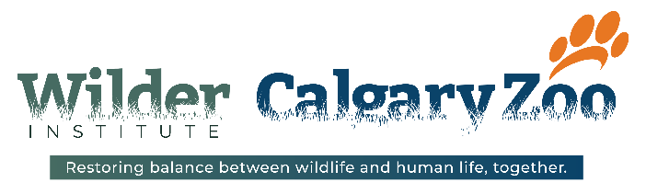

Performer, Theatrical Visitor Engagement

Bring your experience in the performing arts to the Wilder Institute/Calgary Zoo as you make memories for our visitors this summer! Our Visitor Engagement department is looking for enthusiastic Theatrical Visitor Engagement Performers. The successful candidates will be responsible for facilitating theatrical moments centered on highlighting Wilder Institute/Calgary Zoo conservation with visitors during zoo-nique moments, facilitating visitors through surprise and delight moments, and providing exceptional customer focused experiences for zoo guests in a theatre-based way.

Our Mission | Take and inspire action to sustain wildlife and wild places
Our Values | Effective collaboration and communication, honesty and integrity, customer focus, safety, and conservation
Contract:
Start Date: ASAP
End Date: September 5, 2022

What you will do:
- Collaborate with the Coordinator, Theatrical Visitor Engagement to create conservation focused, theatrical experiences on park
- Facilitate magical, memory making moments as “Surprise and Delight” experiences
- Develop an understanding of the animals, park attractions and amenities, and conservation efforts to further theatrical programming ideas.
- Identify opportunities to engage with visitors and enhance their zoo experience through a curiosity lens
- Participate in the trial and improvement of different experiences and moments
- Work collaboratively with zoo volunteers to enhance the visitor experience
- Enhance moments with your unique skills such as singing, strumming, puppeteering and costuming.
- Perform all duties in a professional manner according to zoo policies and guidelines
- Maintain a safe, clean working environment for animals, visitors, and zoo staff
- Other duties as assigned to support zoo operations.

What you will bring:

- 2-5 years of demonstrated experience in the performing arts
- Post-Secondary Education in Performing Arts is preferred
- Experience devising and/or creating original theatrical material an asset
- 1 or more years in customer service an asset
- A love of conversation and demonstrated storytelling ability
- Commitment to excellent customer service and the ability to find solutions to support visitors
- Student mentality, and the desire to learn new skills

Working Conditions:

- Ability to walk across the Zoo from one exhibit to another, stand on your feet for extended periods of time, and be exposed to all weather conditions and various climates
- Some heavy lifting required, pulling/pushing of wagons, and moving of supplies
- Exposure to outdoor work in all weather conditions including extreme heat, cold, rain, snow, or smoke
- Working indoors in climate-controlled buildings including hot and humid environments
The Wilder Institute/Calgary Zoo is an outdoor facility and all staff working at the zoo must be comfortable working in a large variety of outdoor conditions. The Wilder Institute/Calgary Zoo follows the advice of Environment Canada when responding to temperature and air quality issues.
What We Offer:
- Discounts on food, beverage, and merchandise
- Participation in the Staff Pass Benefit Program
- A fun, rewarding work environment and the opportunity to work in a park full of animals from around the world

Are you ready to join one of Canada’s leaders in wildlife conservation?
If this position suits your skills, experience, and personal attributes, we want to talk to you!
Apply by doing the following:
- Watch this video about the conservation work being done at the Wilder Institute/Calgary Zoo. (https://www.youtube.com/watch?v=8J1VH1MBXm0)
- Submit your resume with a cover letter via our online application system.
- Submit a 4-5 minute video telling us about yourself including any special skills and interests you have outside of work, and what interests you about this position

Applicants must be legally entitled to work in Canada.
If this position is a fit for you, we encourage you to apply with a resume and cover letter no later than Applications will remain open until all positions are filled. https://app.jobvite.com/j?cj=oxmLifwG&s=Calgary_Arts_Development
All candidates are thanked for their applications and advised that only those selected for interviews will be contacted.

