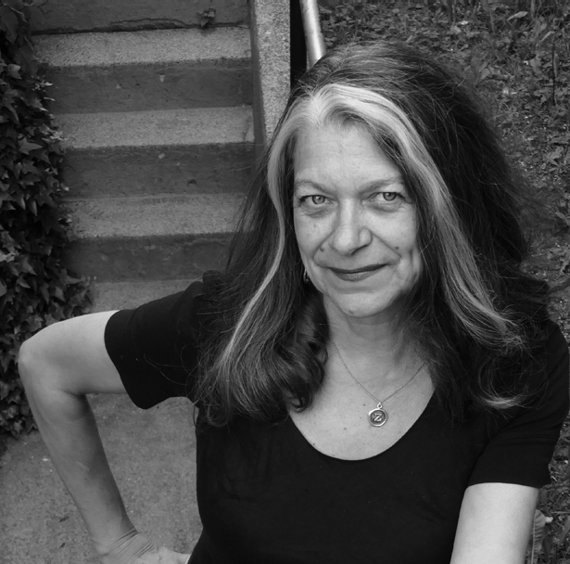
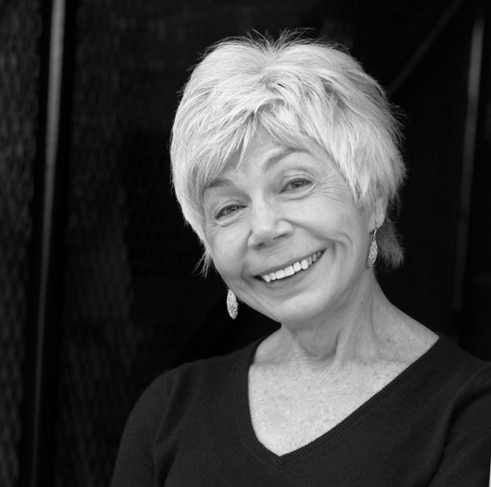
Meet the 2022 Prose and Poetry Contest Judges Zsuzsi Gartner - Prose Jane Munro - Poetry

is pleased to announce Zsuzsi Gartner as the Prose contest judge, and Jane Munro as the Poetry contest judge for 2022.

Zsuzsi Gartner is the author of the Scotiabank Giller Prize finalist Better Living through Plastic Explosives and of the widely acclaimed story collection All the Anxious Girls on Earth. Her novel, The Beguiling (Penguin Canada), was a finalist for the 2020 Writers Trust Fiction Prize and a Globe & Mail Best Book of 2020. She is also the editor of the award-winning fiction anthology Darwin’s Bastards: Astounding Tales from Tomorrow and was the inaugural Frank O’Connor International Short Story Fellow for Cork, Ireland, in 2016. She lives in Vancouver.

Jane Munro’s sixth poetry collection, Blue Sonoma (Brick Books), won the 2015 Griffin Poetry Prize. Her newest book, a prose memoir, is Open Every Window (Douglas & McIntyre, 2021). Glass Float (Brick Books, 2020) is her most recent poetry collection. Munro’s previous poetry books include Active Pass (Pedlar Press), Point No Point (McClelland & Stewart), and Grief Notes & Animal Dreams (Brick Books).

$2000.00 in Prizes
Contest entry deadline April 30, 2023
Enter by mail or online at www.freefallmagazine.ca

