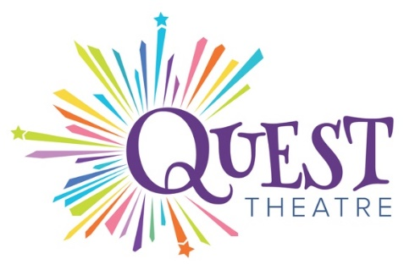
Audition Notice for
SNOW WHITE
By Greg Banks
Nikki Loach is conducting auditions for
Quest Theatre’s Alberta Elementary School Tour, Fall 2024
For distribution Friday, April 26, 2024

Preliminary Rehearsal and Show Dates
Rehearsal Dates (12 days) October 10 - 23, 2024
9:00 am – 5:00 pm, Monday through Saturday, Sunday off,
Tour Dates (4 weeks) Oct 24 - Nov 24, 2024
Public Presentation Dates (2 days, 3 shows) November 8, 9 2024
Hold Over Dates (1 week) Nov 25 - Dec 1, 2024

Characters
Performer 1: Snow White A female presenting performer of any age or ethnicity.
Performer 2: Four A male presenting performer of any age or ethnicity.
In this two-hander, both performers play all characters in the play including Snow White, Queen, Stepmother, Huntsman and multiple Dwarfs. Physicality and creativity are assets.

Submission Information
If you would like to be considered for a Snow White audition, please send an electronic resume, and headshot to Artistic Director Nikki Loach at artistic-director@questtheatre.org. Please make the subject heading: Snow White Submissions 2024. Deadline for submissions is Monday May 6th, 2024, at 5:00 pm.

In-person auditions will take place Thursday May 16th, 2024. Candidates are asked to prepare the following:
- Audition sides supplied by Quest Theatre
- An acapella song of your choice.

Submissions are open to Equity and Non-Equity artists. We are currently only considering submissions from Alberta artists. As Quest Theatre is a professional touring company, artists must perform during the day and cannot be enrolled as full or part-time students as of September 2024.

Quest encourages all artists to explore theatre for young audiences as part of their ongoing practice. We are open to inspiration from any artist who is passionate about sharing their love of theatre with young people. We welcome artists of all races, ethnicities, genders, sexual orientations, religious affiliations, and abilities, as these represent the audience we serve. Discover more about Snow White or Quest Theatre by visiting our website at www.questtheatre.org

Quest Theatre is a member of the Professional Association of Canadian Theatres and operates within the jurisdiction of the Canadian Theatre Agreement. Equity members cast in any production will be engaged under an Equity form of contract.
Please direct your questions or accessibility needs to
Artistic Director Nikki Loach at artistic-director@questtheatre.org

