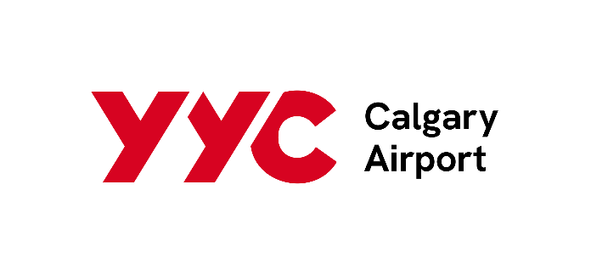

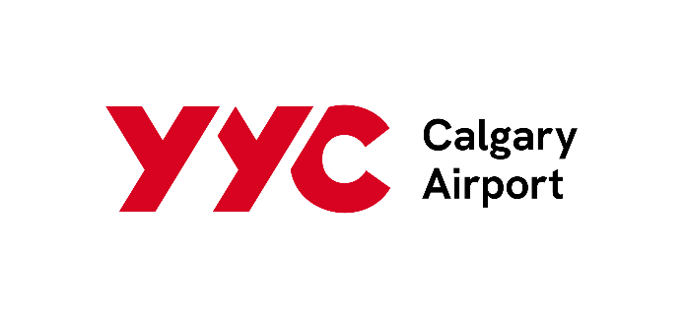
2025
Artwork Creation Services
Request for Quotation – Collaborative Art Installation for Calgary Airports Staff Lounge

Overview
Calgary Airports (formally The Calgary Airport Authority) invites proposals from qualified local artists or creative design professionals for the concept development, design, fabrication, and installation of a custom art piece for its newly developed staff lounge. This initiative aims to foster collaboration by incorporating contributions from Calgary Airports staff, while celebrating the pride, unity, and spirit of the YYC community.

Project Objective
The commissioned artwork is a co-created piece with Calgary Airports employees. The selected artist will be expected to actively incorporate physical contributions from staff—such as materials, objects, or creative input—into the final artwork. It should serve as a visually compelling and emotionally engaging centerpiece that reflects the essence of YYC and the dedicated individuals who support its operations. The design should thoughtfully integrate elements of Calgary’s cultural identity, aviation themes, and seek collaborative input and participation from staff members across various departments.

Scope of Work
The selected artist or designer will be responsible for:
• Refining creative concepts in alignment with initial ideas provided by YYC.
• Designing a modular or portable art piece suitable for the staff lounge environment.
• Facilitating meaningful crew participation in the creative process (e.g., collecting contributions, guiding collaborative components). This may include seeking and collecting physical contributions from staff, for final installation.
• Managing all aspects of production and fabrication and co creation with staff.
• Overseeing final installation within the designated lounge space.

Design Considerations
• The artwork should be modular or portable to accommodate potential relocation or reconfiguration.
• Incorporation of lighting, layering, or other dynamic elements is encouraged to enhance visual depth and movement.
• The final piece should evoke a sense of energy, pride, and inclusivity—symbolizing the heartbeat of YYC and its people.
The piece must include physical contributions from employees in some way.

Submission Requirements
Interested applicants are asked to submit the following:
• A portfolio showcasing relevant past work.
• A brief proposal outlining initial concepts and creative approach.
• An estimated project timeline and budget.
• Full contact information.
- Concept sketches are welcome.

Schedule Requirements
This project aims to begin October 2025, with final installation in January 2026. Submissions will be accepted for a period of two weeks beginning September 24, 2025, until the closing date of October 10 at 4:00pm.

Calgary Airports Contact Information
Further questions or clarifications can be directed to
Lauren Beaudry
General Manager, Facility and Workspace Services
Laurend@yyc.com
403-710-3246

